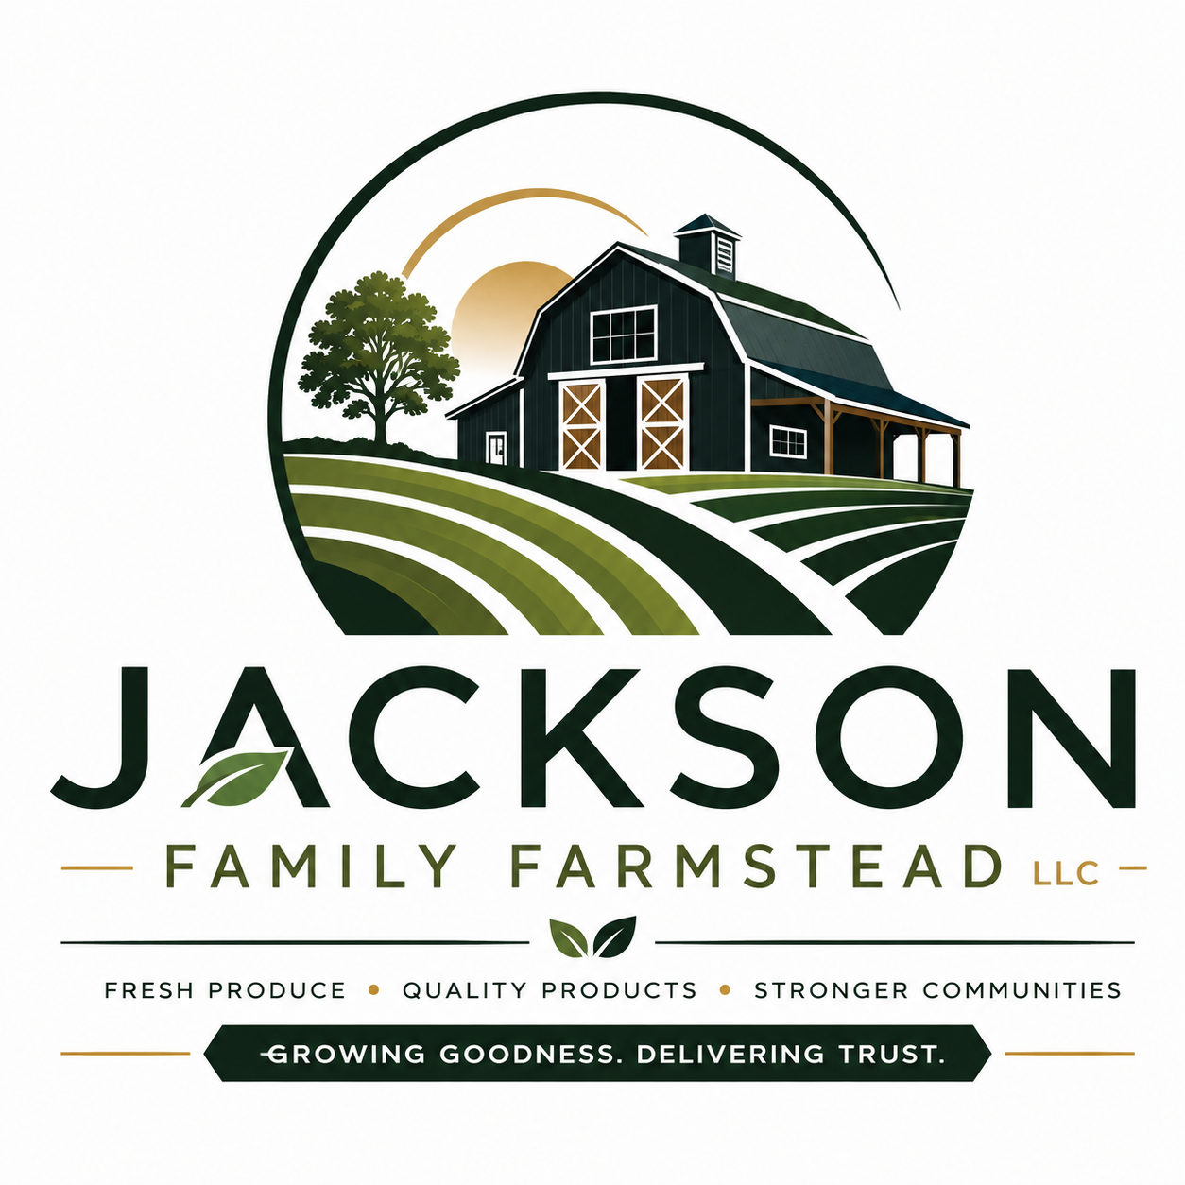

JACKSON FAMILY FARMSTEAD LLC
Fresh Produce • Agricultural Products • Government Contracting
Growing Goodness. Delivering Trust.
COMPANY OVERVIEW
Mississippi family-owned small business supplying fresh fruits, vegetables, poultry products, and agricultural sourcing solutions to federal, state, and local government agencies.
CORE COMPETENCIES
- Fresh fruits & vegetables
- Seasonal produce
- Bulk produce supply
- Poultry products
- Produce packaging & distribution
- Agricultural procurement
- Farm-to-government supply
- Coordinated livestock & processed agricultural sourcing
DIFFERENTIATORS
- Family-Owned Small Business
- Mississippi-based supplier
- Reliable sourcing network
- Flexible fulfillment
- Quality & food safety
- Responsive customer service
PRIMARY NAICS
111219 • 111339 • 111998 • 424480 • 424440 • 311421
CERTIFICATIONS & REGISTRATIONS
- SAM.gov Registration – Active (All Awards)
- UEI: DTT9Z9GNCPT6
- CAGE: 18TP1
- Mississippi MAGIC Vendor – VEND215186501
- Listed in the Mississippi Minority Business Registry
CONTACT
Shamika Jackson
600 Eddie Lee Smith Dr
Holly Springs, MS 38635
(662) 400-9937
shamika@jacksonfamilyfarmstead.com
https://jacksonfamilyfarmstead.com

